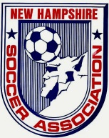
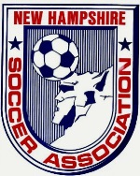
New Hampshire Soccer Association
Board Meeting Minutes
September 2013 Board Meeting

Attendees: Bob Willey, candia campbell, Bill Thornton, John Ferreira, Dan Wyborney, Mark Sadler, Tom Haydock, Cory Halvorsen, Ric Marion, Diane Hebert, Jeff Cousineau, Mark Chagnon

Meeting called to order at 6:40 PM

Secretary Report: Written report attached. Dan Wyborney made motion to accept report and candia campbell seconded. All approved.

Treasurer’s Report: Written report attached. Motion made by Bill Thornton to accept for audit. Tom Haydock seconded. Accepted. John Ferreira to give Treasurer, Diane Hebert access to financial transactions and reports.

Executive VP Report: Written report attached.

VP of Recreation: Written report attached.

VP of Competitive: NHSL league has started.

VP of Adult: Written report attached. A team in the Over The Hill league, which is not registered with the state, wants a certificate of insurance but they will not be granted one.

VP of Indoor: Written report attached.

President’s Report: Written report attached.

State Coach of Education: Written report attached.

State Coach of ODP: Written report attached.
Bill Thornton, made a motion to adopt Jeff’s 2014 Fee Schedule & Philosophy and Purpose, as outlined in Jeff Cousineau’s memos. Tom Haydock. seconded. All approved.

Bill Thornton, made a motion to accept Jeff Cousineau’s list of ODP coaches (whole group). Mark Chagnon seconded. All approved. Dan Wyborney. abstained.

State Referee Committee: Written report attached. Late Nov/Dec classes will resume.

State Administrator: Written report attached.

State Registrar: Written report attached.

Risk Management Report: Written report attached.

Ongoing Business:

NHSL league kicked off well.
Working on ref issues (need scores entered, no shows, late, etc.), and other discrepancies, but these are not unusual for any league. Other issues center around teams wanting (needing) to change division. Requests after the deadline affect multiple people, teams, etc., and is a huge undertaking. Need to get the U8/U9/U10 scores un-posted. Cory Halvorsen is working on all these items.
Bob Willey gave Cory Halvorsen kudos for the great work done for the NH Soccer League. The first LOC meeting to take place Sunday, Sept. 15th, at SNHU at 6:30 PM. The LOC will determine where the fall playoffs will be held (Seacoast fields or other fields). Clubs may not get a credit or refund for ref fees not paid out because their league cost has already been reduced. Financial assistance for clubs will be deferred for 2 years to allow for proper filings, documentation and analysis to be completed.

GSYSL application tabled until next meeting pending more information.

NHSA Award nominations are coming in. More to follow. Ceremony is 11/15/13 at SNHU. Menu choices to be determined. Mark Chagnon is working on this.

AGM tentatively scheduled for 2/8/14.

New Business:

Region 1 meeting: Let Carla know if you are attending. Reserve hotel room now.

Bill Thornton made motion to accept the $2K offer for the gray car – “AS IS, Logos removed”. Mark Chagnon seconded. All in favor.

USYS Meeting. Let Carla know if you are attending. Reserve hotel room yourself.

Good of the Game:

Meeting adjourned 9:30 PM

Respectfully submitted,
Cookie Hebert (for Carla Nastri)
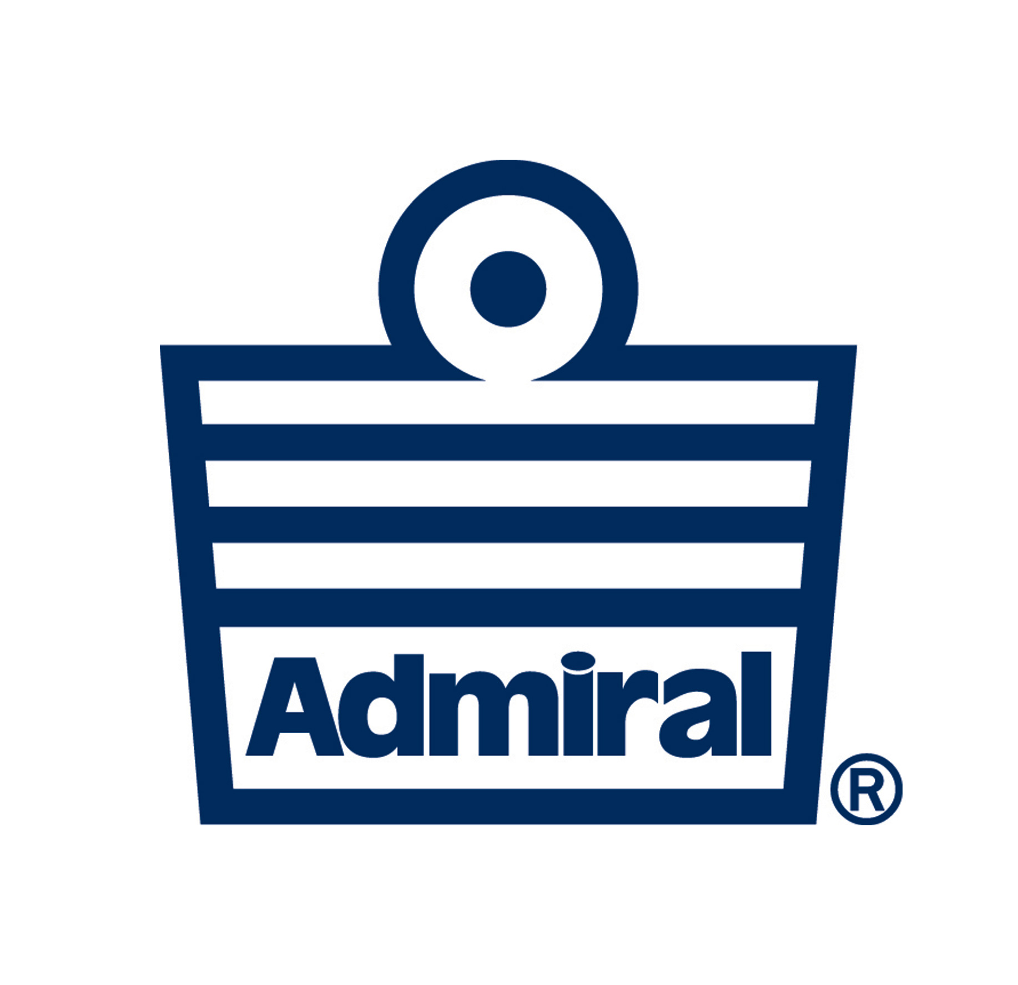
Treasurer

